Client Name:
Anita Burns (husband name Don)
Client Address:
1201 Star St, Bryan, TX 77803
Phone Number:
979-329-8131

Distance from the Church:
2 miles – 8 minutes

Description of the work:
Demo and repair two decks
Steps will be built for both
Watch for snakes

** Water line under front deck **

Site Pictures

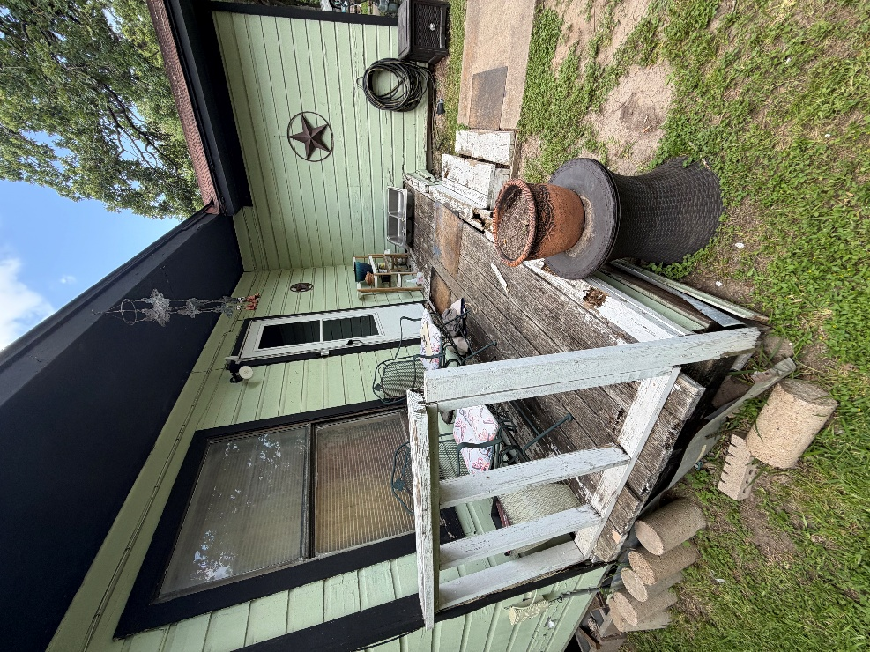
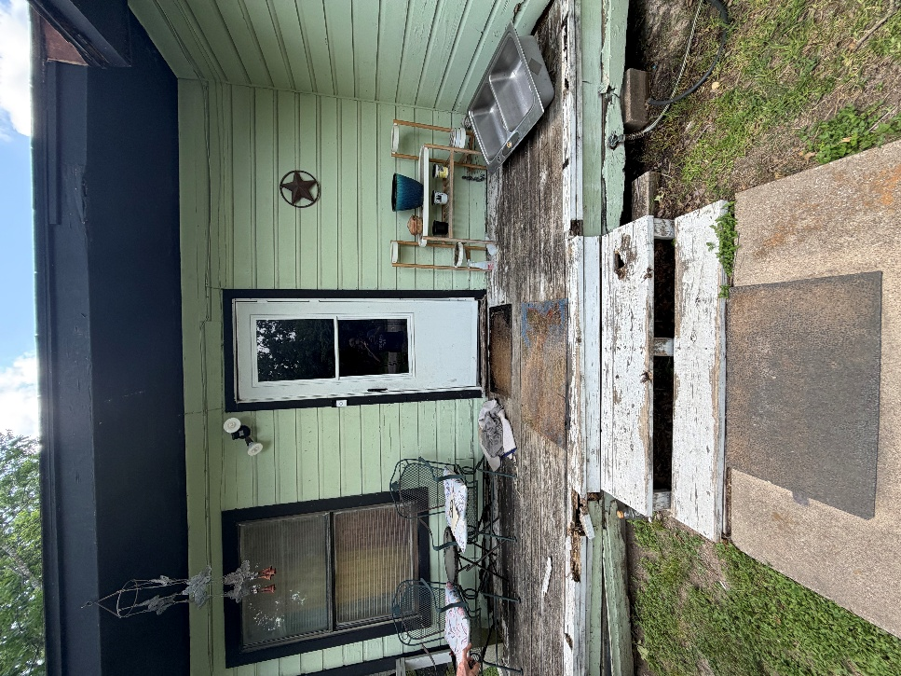
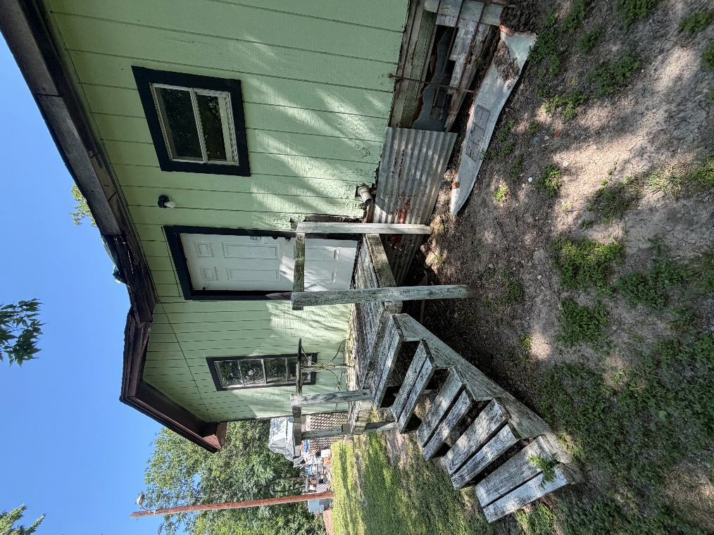
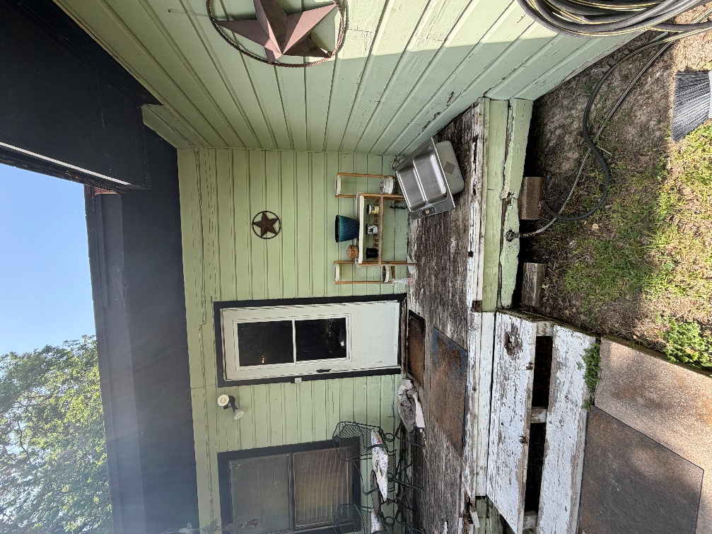
Rendered Project
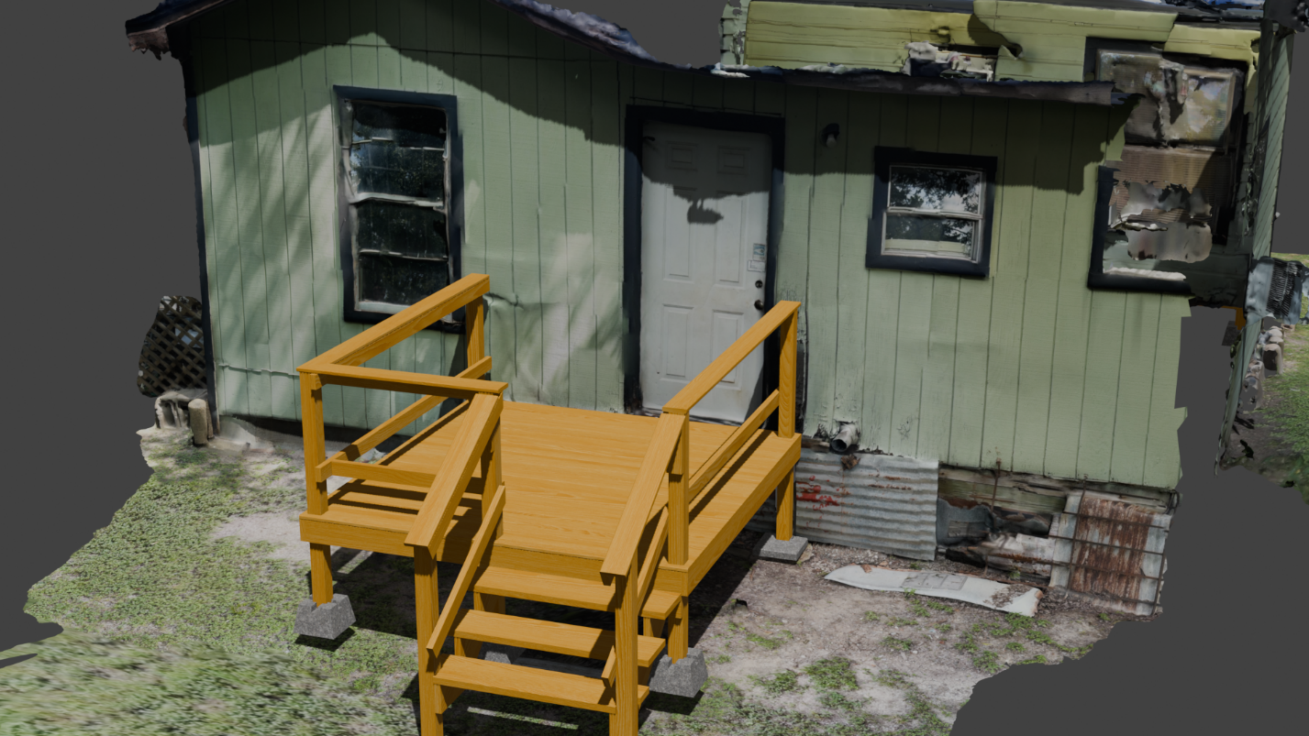
“Build to site not to plan”
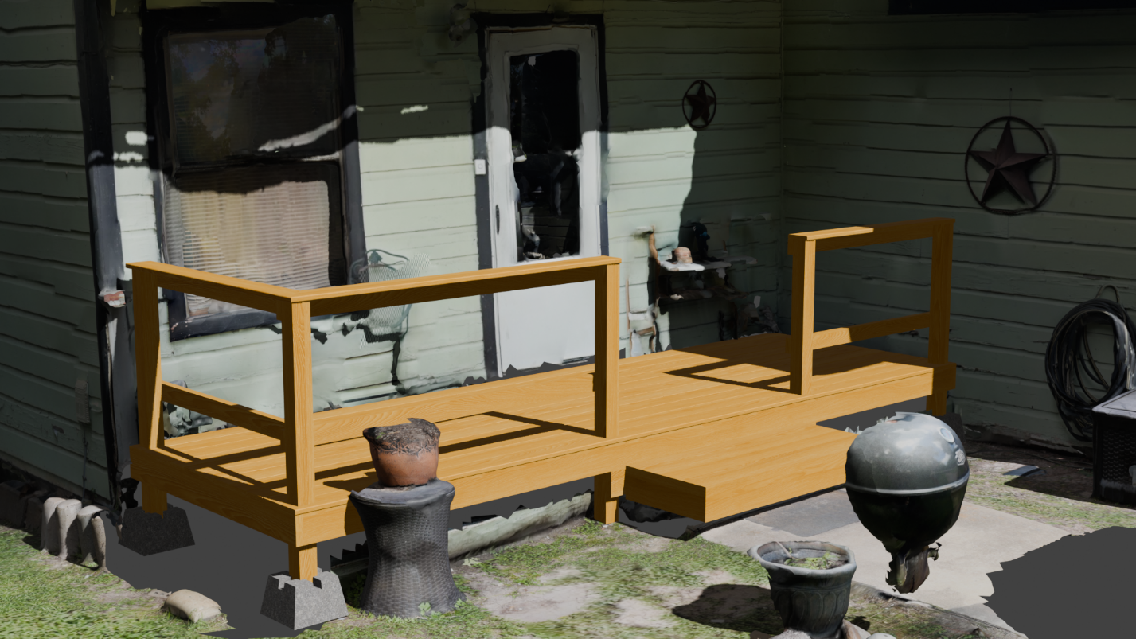
Building Notes
- Front Deck
  - **Beware of the water line in the deck**
  - The biggest challenge is working with the under frame, there is plenty of extra lumber
  - Step vs stairs
    - Lumber is provided for both, if the distance between stairs and the surface of the concrete is less than 15 inches
    - If you cut stringers, you will need 3
  - Ask the client if the want handrails all around!
- Back Deck
  - Simple demo and rebuild

